# CS 255 System Design Document

## UML Diagrams

### UML Use Case Diagram

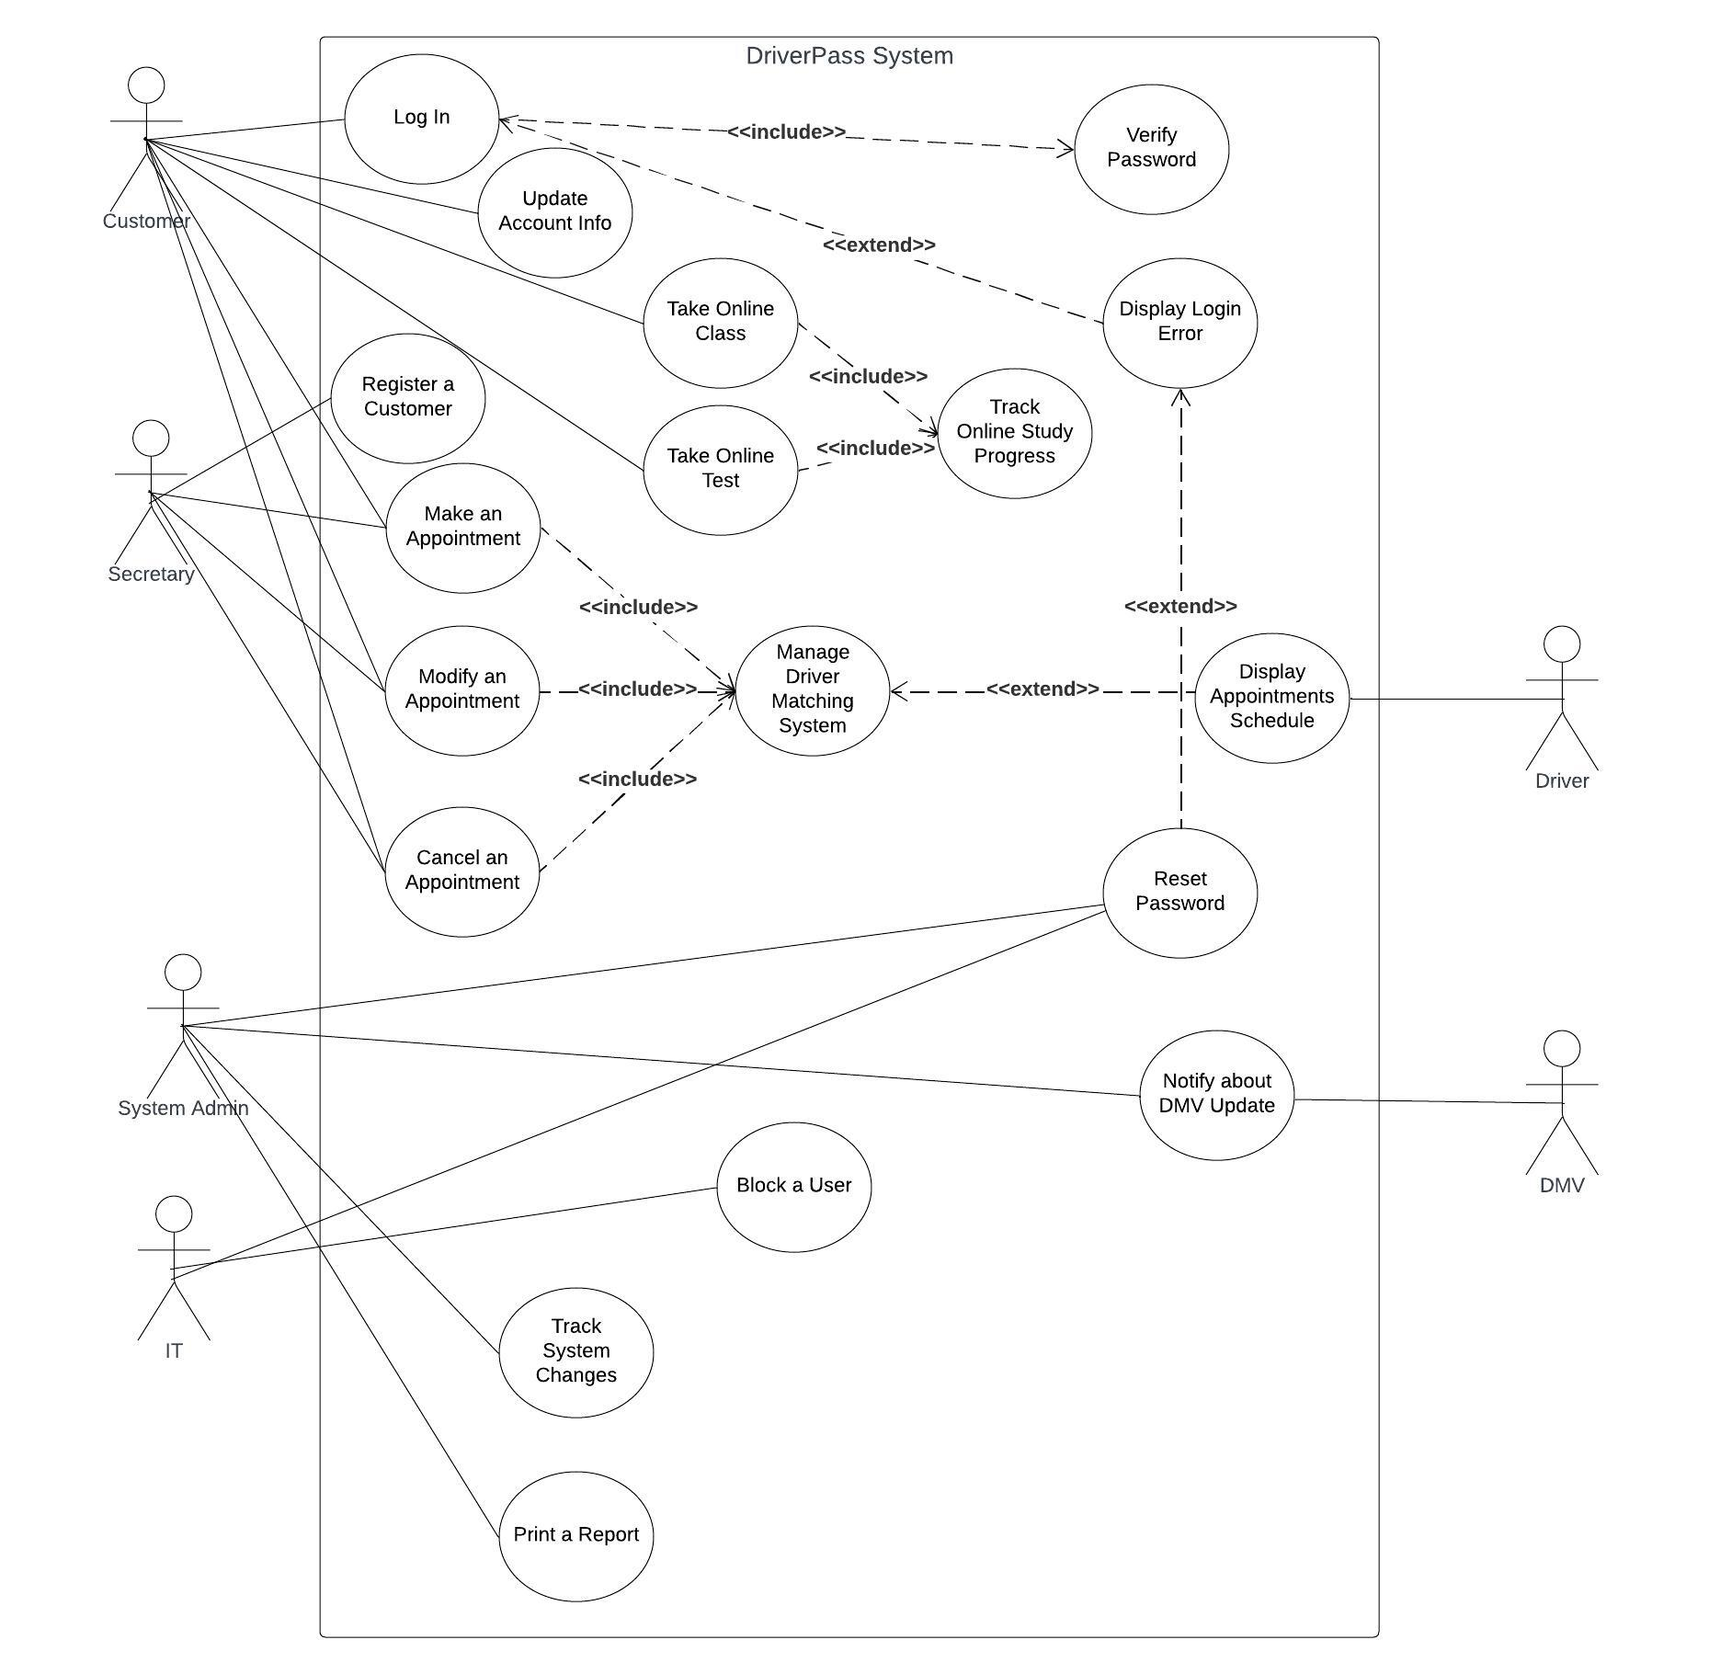

### UML Activity Diagrams

**User Login**

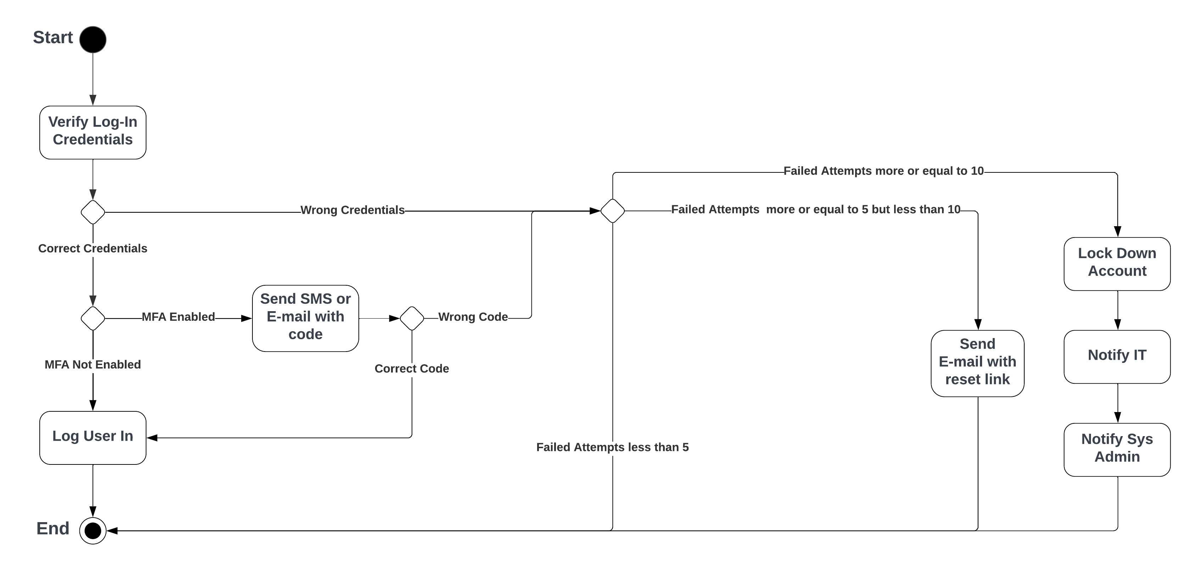

**Cancel an Appointment**

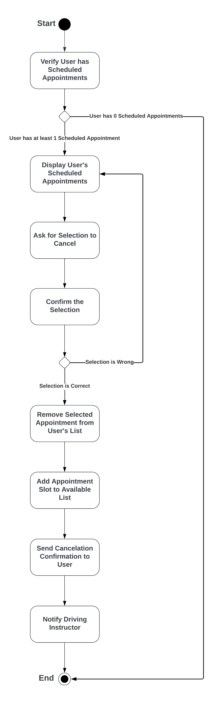

### UML Sequence Diagram

**Cancel an Appointment**

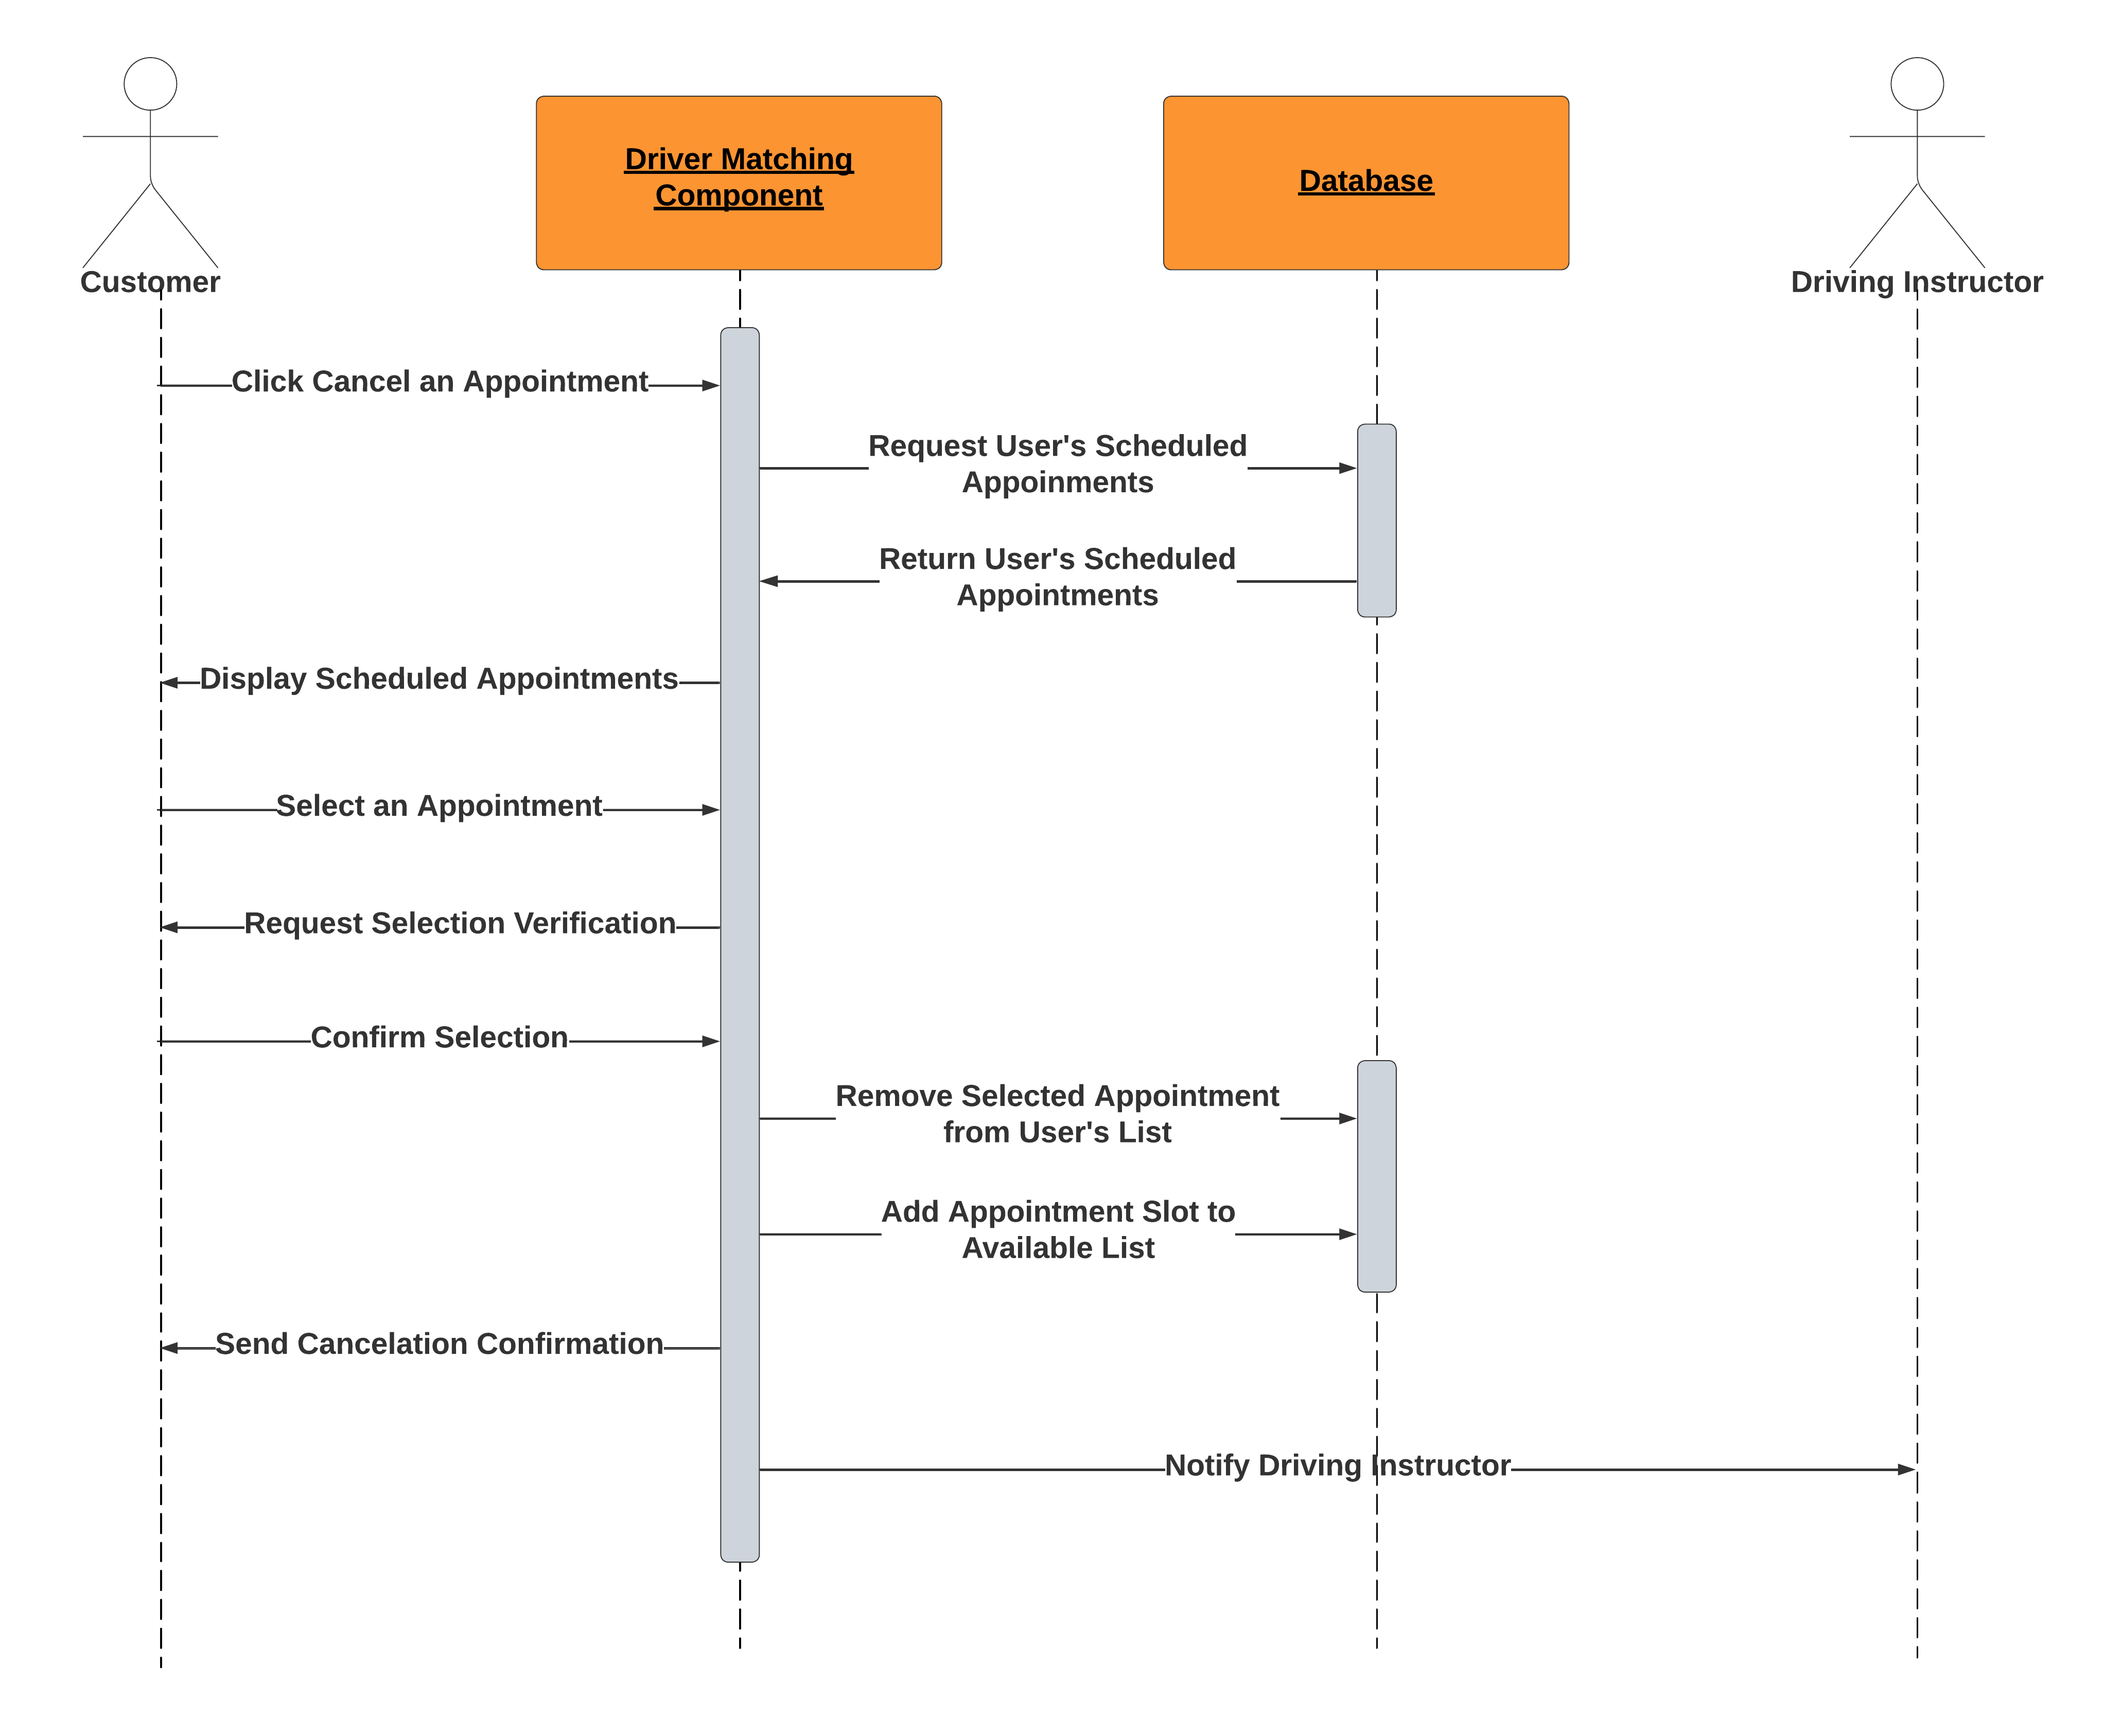

### UML Class Diagram

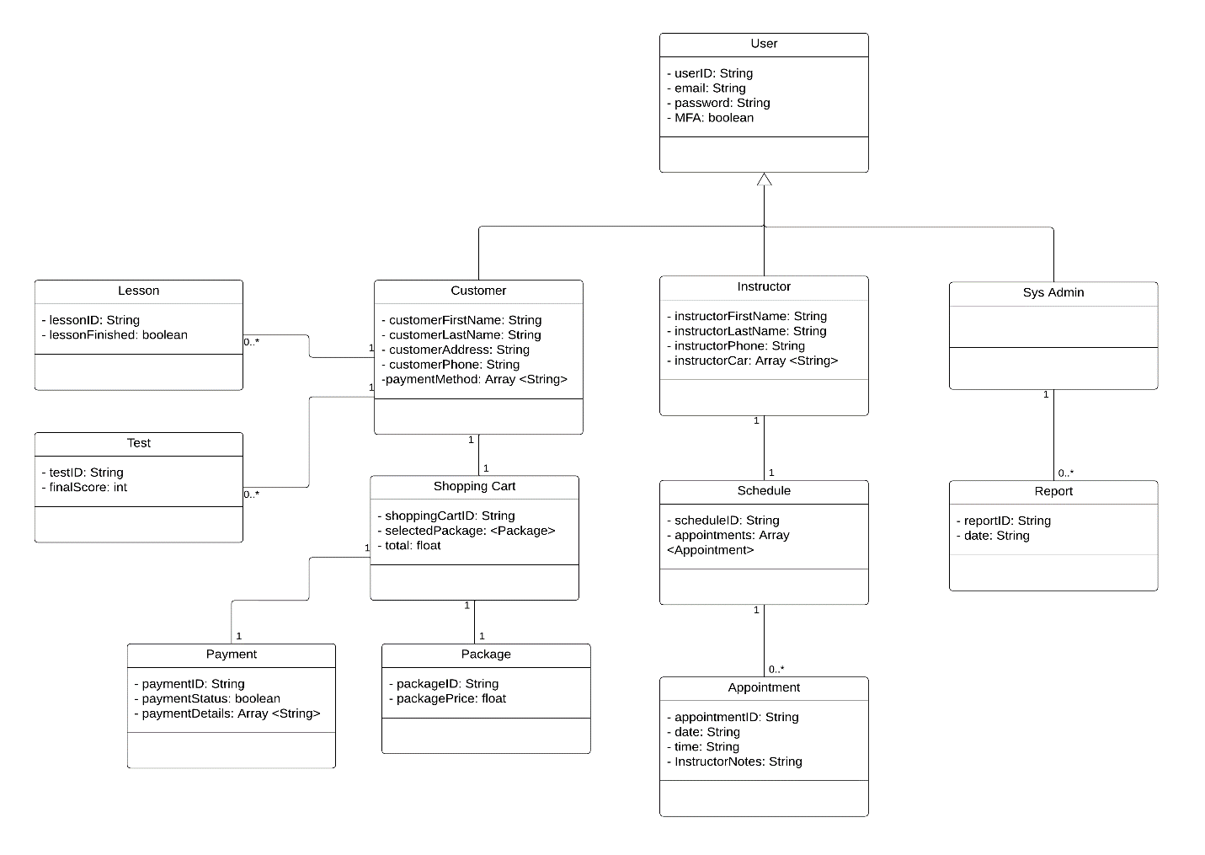

## Technical Requirements

* Cloud-based hosting platform to ensure scalability, reliability, and high availability (for example, AWS, Microsoft Azure, Google Cloud Platform).
* Outsourced backup and security management to minimize technical issues.
* Consistent internet connection required.
* Integration with a payment processing service for handling transactions securely.
* Computer with a web browser required for office use to access the interface.
* Mobile devices with internet connectivity for user access.
* Robust database management system (DBMS) for storing user information, course data, appointments, and system reports (for example, MySQL, Oracle, or MongoDB).
* Connectivity with the DMV for receiving updates on rules, policies, and sample questions.
* Secure data exchange protocols to maintain confidentiality and integrity.